Curriculum Vitae : Ali Mohammed Salih Mohammed Kadhim

Objective .
To participate and have a position of responsibility in the fields of Electronic and Communications Engineering (Digital and analog electronics, Microcontroller, Digital and analog communications, Antennas, Optical communications, and cellular mobile networks) that enables me to utilize my skills and theoretical expertise to serve university teaching and working.
Personal Information .
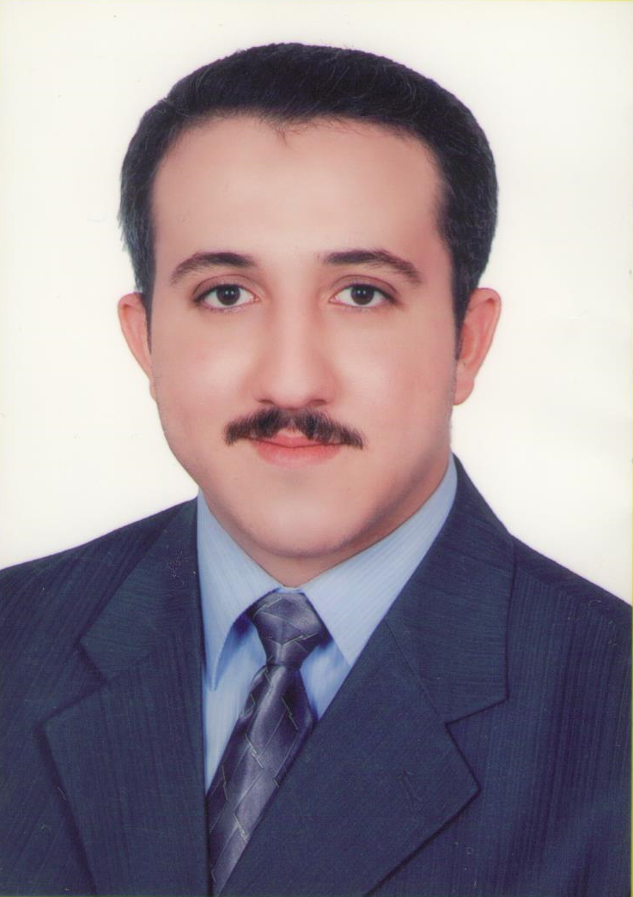
Academic degree: Assistant Lecturer
ORCID : 0000-0003-4056-8250
h – Index: ( 1 ) calculated by Google Scholar
Birth Date & Place: October, 15, 1985 – Iraq
Nationality: Iraqi
Marital Status: Married – Two children
Mobile: Iraq\+964 7902983108 \ +9647703997477
Email: alimsm22@gmail.com and ali kadhim@engineering.uodiyala.edu.iq
Website: www.uodiyala.edu.iq
License: Iraqi International Driving License.
Postal address: Department of Electronic Engineering, College of Engineering, Diyala University, Baqubah City, Diyala Governorate, ZIP 32001, Iraq.
Professional Strength and Skills .
- Very effective in Digital and Analog Electronics, Microcontrollers, FPGA, Power electronics.
- Wide theoretical knowledge in most subject of electronic and communications engineering such as Digital communications, Digital signal processing , Antennas and propagation, Cellular mobile networks, Optical Communications, and Radar.
Educational Qualifications .
- Ms.C. Electronic and Communications Engineering 2009-2012 Institute of Laser for Postgraduate Studies – Baghdad University-Iraq. (English Curriculum).
- B.Sc. Electronic Engineering 2002-2006 College of Engineering – Diyala University - Iraq. (English Curriculum).
Training and Courses .
- Training course for three months in Optical Communications and Quantum cryptography, Milano University, Italy. 2011 – 2012
- Training course for three months in Computer networks, Cisco Networking Academy Program:
CCNA 1 Network Fundamentals, University of Baghdad, Iraq. 2010 – 2011
- ILETS English Language Certificate - Erbil – Iraq – 2010.
- Computer Programming Course for one month in Diyala University – Iraq - 2009.
- TOFEL exam training course for one month in University of Technology – Iraq - 2008.
Languages .
- English: Written and spoken (Very good)
- Arabic: Mother tongue
Published Research Papers .

No | Title of research | Journal name | Publisher or hosting | ISSN
1 | Innovative method to investigate how the spatial correlation of the pump beam affects the purity of polarization entangled state | Optics Letters | Optical Society (OSA) | 1539-4794
2 | Design and implementation of tracking system using wireless and laser technologies | Diyala Journal of Engineering Sciences, 2015, pp. 471-478 | Published by Diyala University, College of Engineering, Iraq. | 1999-8716

Conferences .

No | Conference | Paper title | Proceeding or journal name
1 | Second Scientific Conference in Engineering Sciences, Diyala University, College of Engineering, Dec. 16-17, 2015. Iraq. | Design and implementation of tracking system using wireless and laser technologies | Diyala Journal for Engineering Sciences, special issue.

For more information visit the following links of Social and Scientific media
Research Gate | https://www.researchgate.net/profile/Ali_Mohammed_Kadhim
Acadimeca.edu | http://uodiyala.academia.edu/AliMohammedKadhim
GoogleScholar | https://scholar.google.com/citations?hl=ar&view_op=list_works&continue=/scholar%3Fhl%3Dar%26as_sdt%3D0,5%26sciupd%3D1&user=kM7KG8AAAAAJ
Facebook | https://www.facebook.com/ali.alansari.520
Publons   | https://publons.com/author/1230842/ali-mohammed-kadhim#profile

